Google Cloud Manual

# Links

Database

<https://console.firebase.google.com/u/0/project/cyberstrike/database/cyberstrike/data>

Storage Bucket

<https://console.cloud.google.com/storage/browser/cyberstrike?forceOnBucketsSortingFiltering=false&project=cyberstrike>

VM

<https://console.cloud.google.com/compute/instances?project=cyberstrike&instancessize=50>

Game When Server is on

<http://35.244.93.81/>

# Moving VM Between projects

1. Ensure user account has access to both projects
2. On the source project, go to disks and select the disk of the VM you want to move

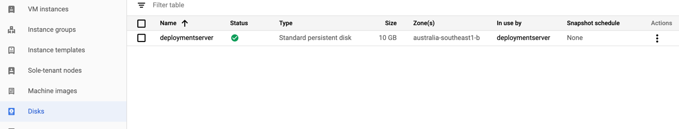

1. Select create image at the top and leave settings default and select create

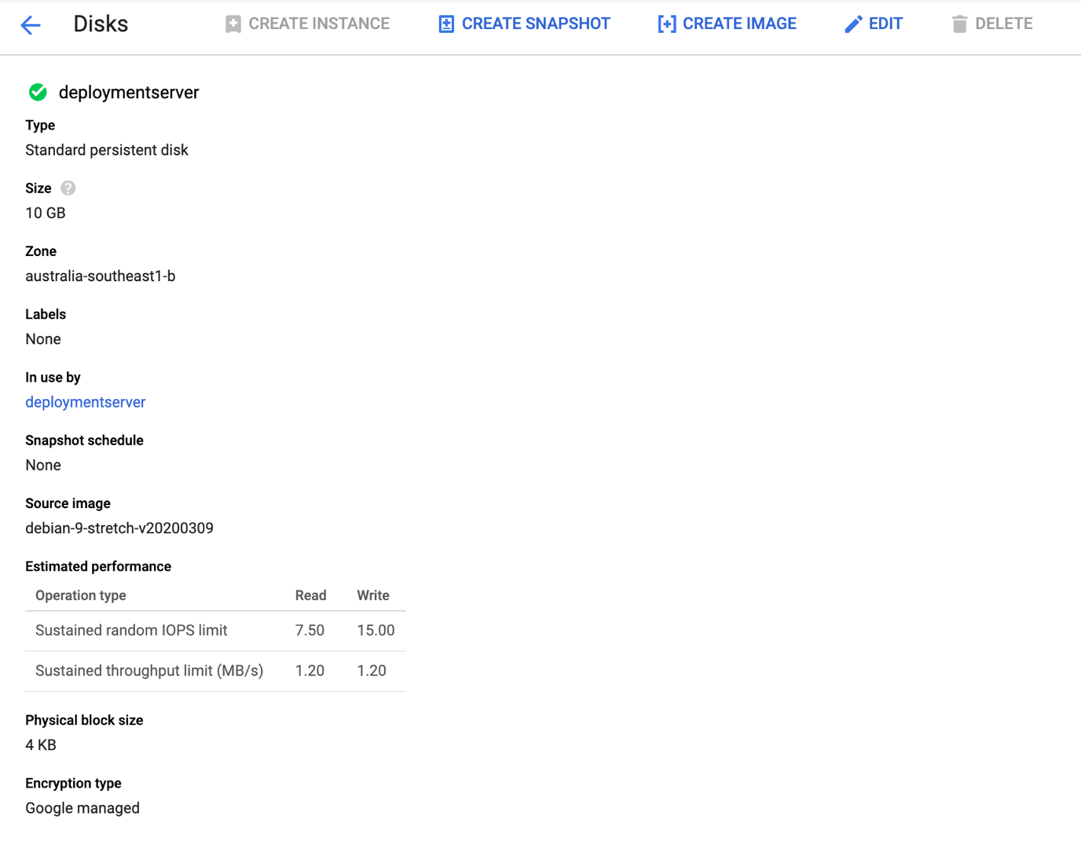

1. On the new project, go to VM instances and create one
2. Customize VM as needed and select change on the boot disk

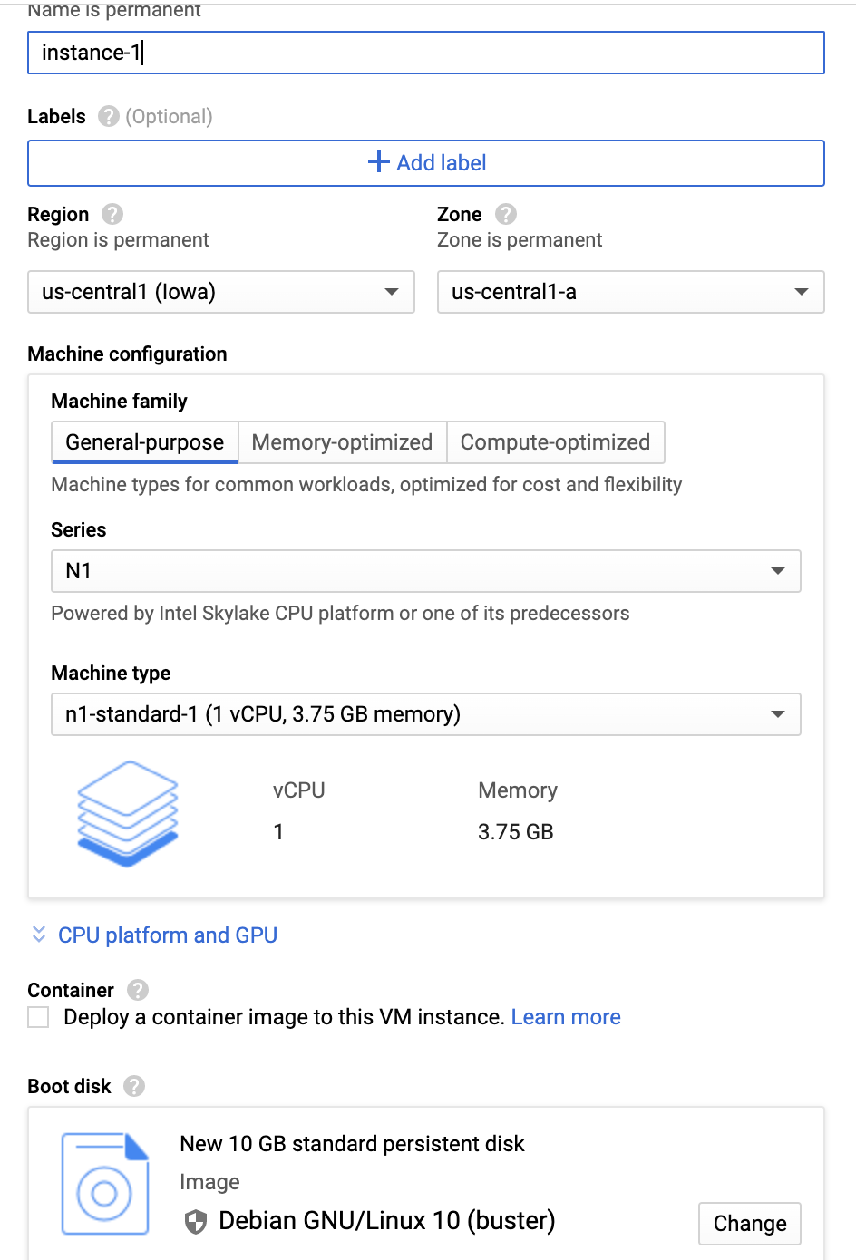

1. Select the custom image, change to the source project and pick the image you want

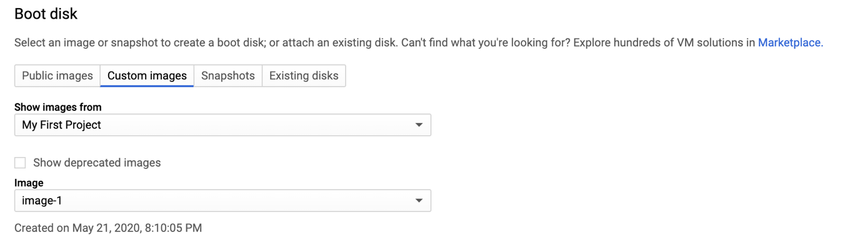

1. You have to allow http and https traffic through for it to accept people going to it
2. Then once you have made the instance you have to make a static IP so it won’t change every time you restart the VM
3. In the side menu, go to external IP addresses

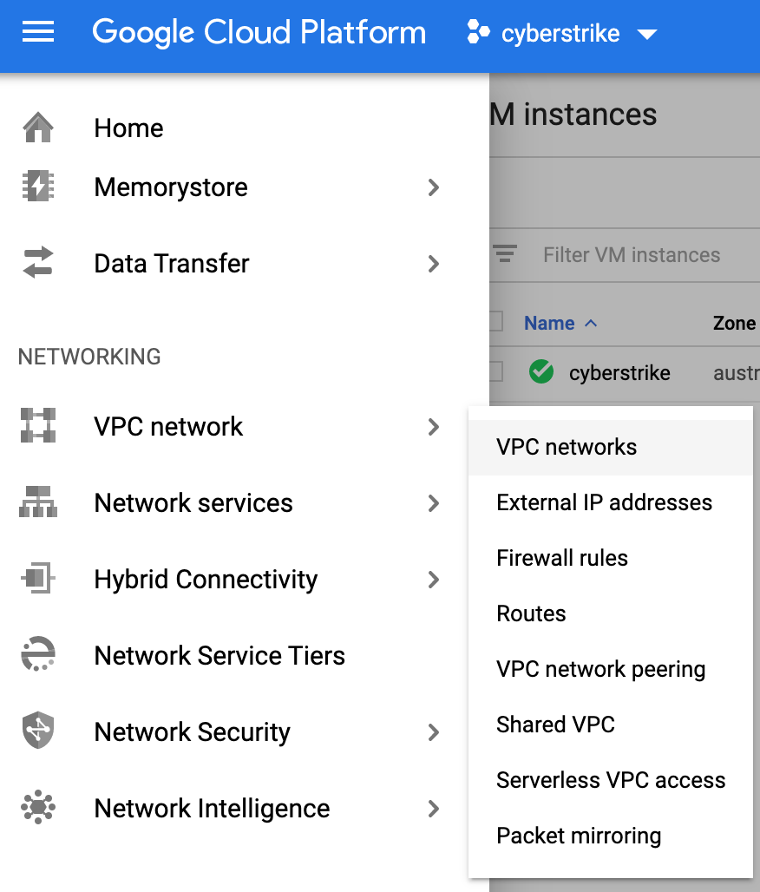

1. Find the one associated with your VM

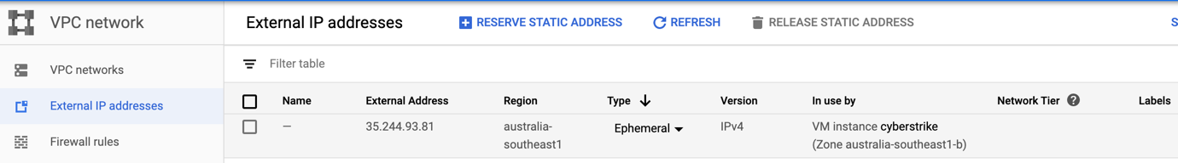

1. Click on the type and change from ephemeral to static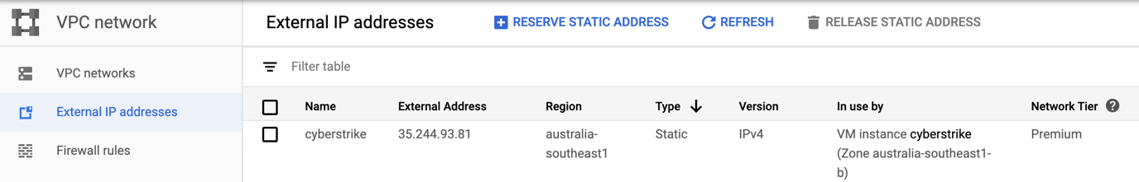
2. Then stop and start the instance and the static IP will be good to go

# Changing the Unity Build on the server

1. After you have created the build and web page to your liking you need to upload it to a google cloud bucket
2. In the side menu go to storage browser (skip to step 5 after this if bucket is already made)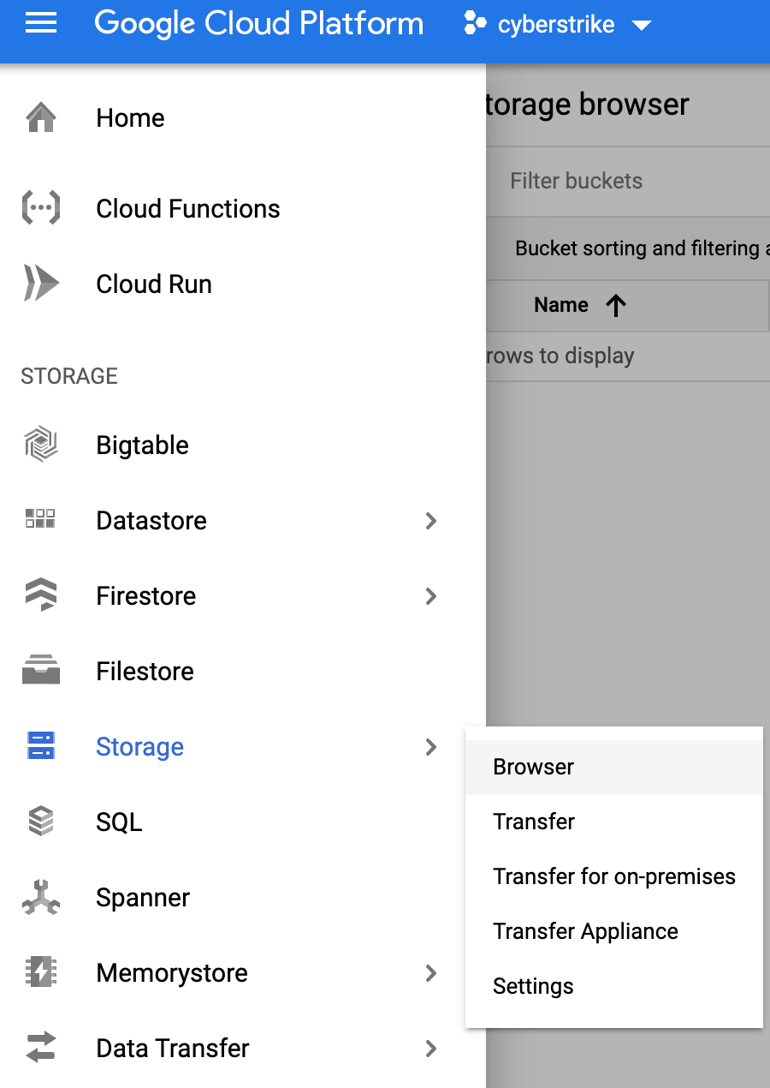
3. Create bucket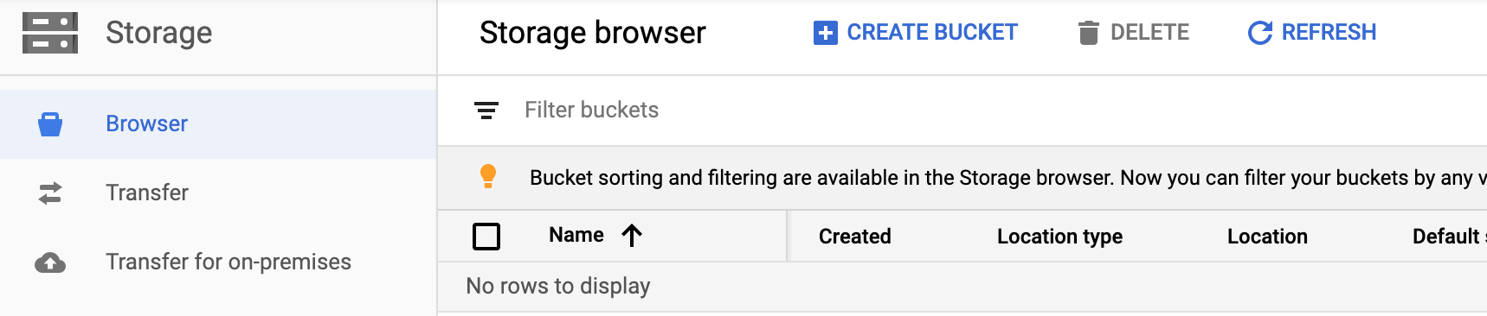
4. Default settings for the bucket work fine, only thing I changed was asia region instead of US
5. In the bucket, hit upload folder and upload the folder created by the unity build

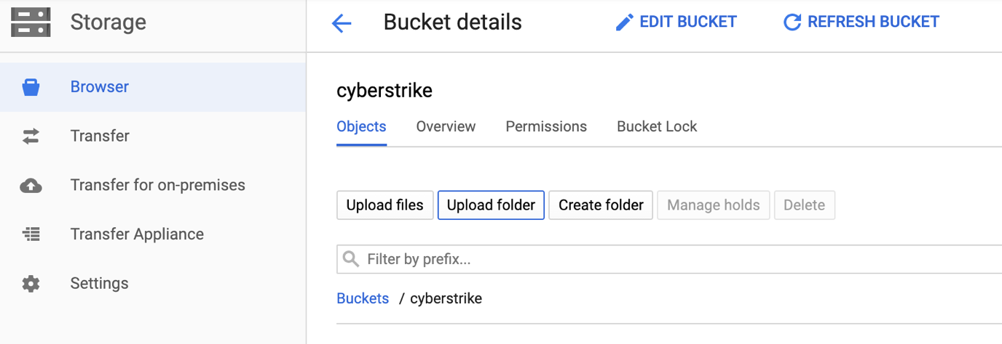

1. Should look like this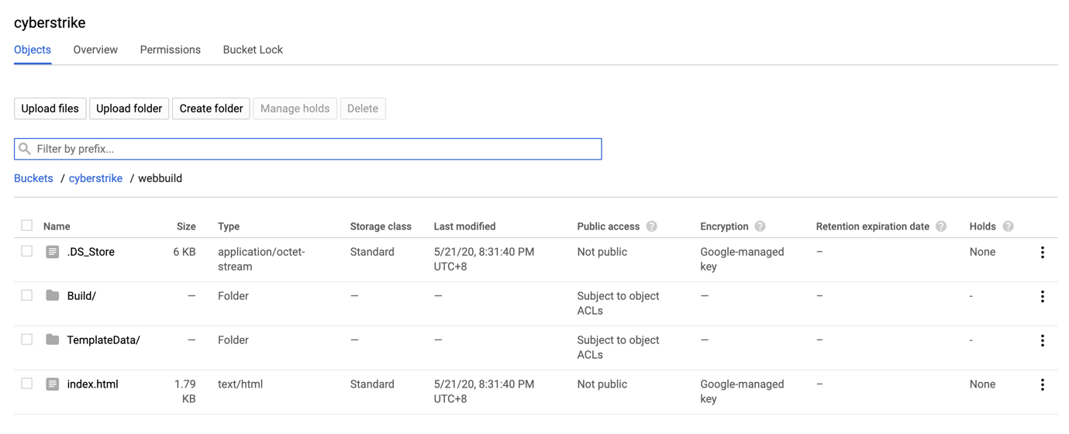
2. Go back to the VM instances and ssh into your instance
3. Remove the old build folder using command: rm -r {name_of_folder} (in mine the name was webbuild)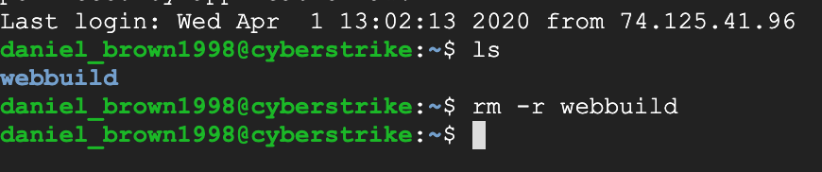
4. Download the new build from the bucket using this command

gsutil cp -r gs://cyberstrike/webbuild .

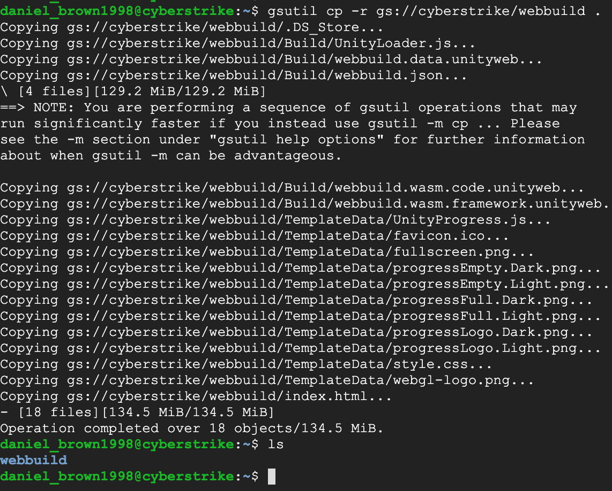

1. Go into the webbuild folder

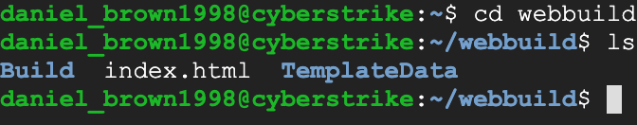

1. Copy the contents of the folder over to the web directory of the server



Command: sudo cp -r Build /var/www/html && sudo cp -r TemplateData /var/www/html && sudo cp index.html /var/www/html

1. Then close the ssh connection, and stop and start the VM instance
2. You may need to delete your cache or use private browsing to see the updates straight away

# Creating a new web build in unity

1. Before updating the build of the game after making changes, if you are not making any changes to the web page, make sure to save a copy of the index.html before doing the new build and save it somewhere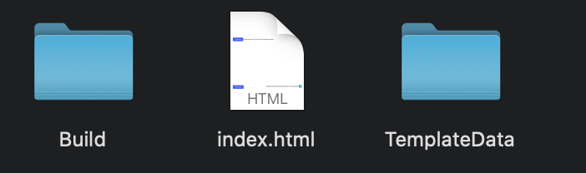
2. In Unity, go to the build settings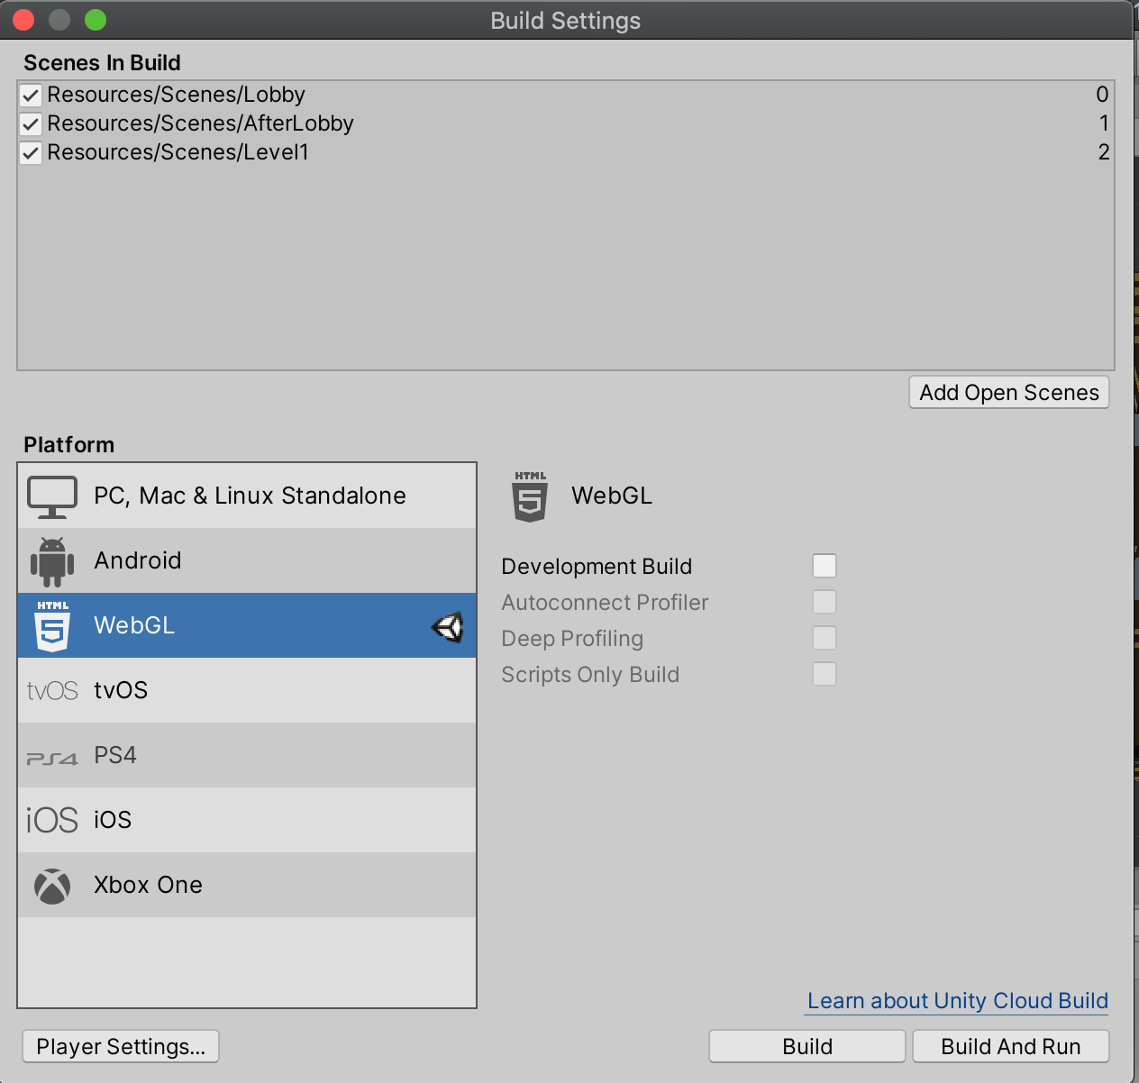
3. Make sure the target is webgl and the scenes are all in the build target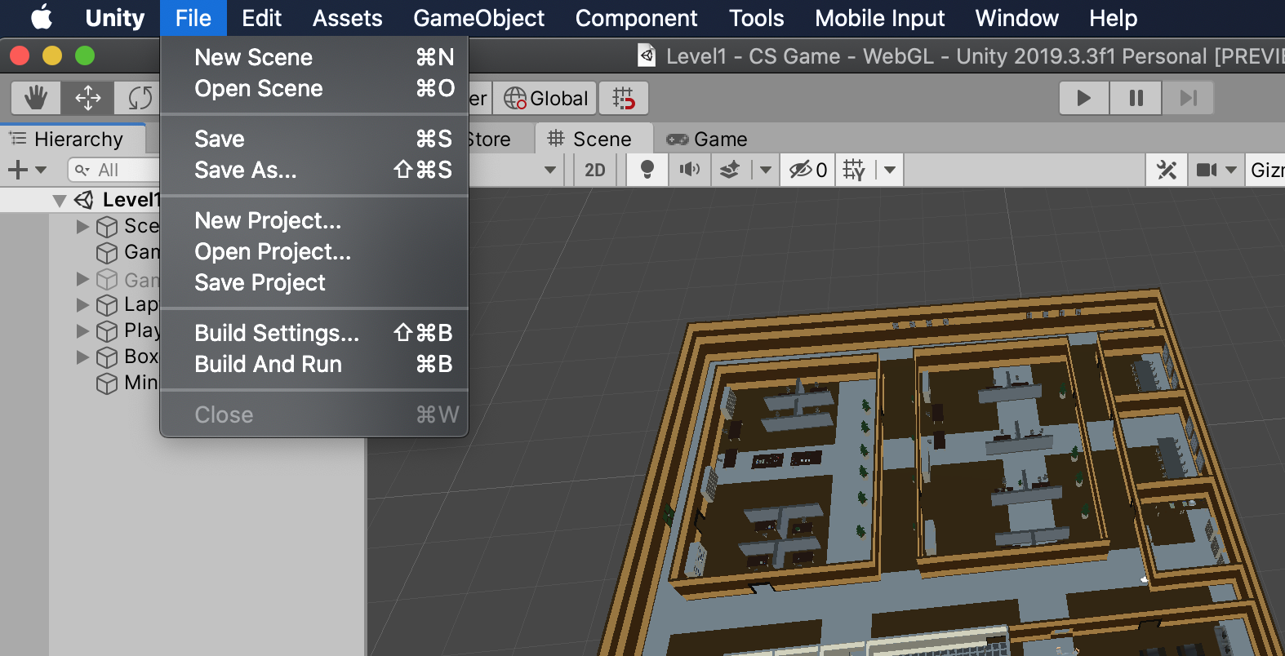
4. Hit build and save it in the project or wherever you want, I just overwrite the old one every time but versioning could be good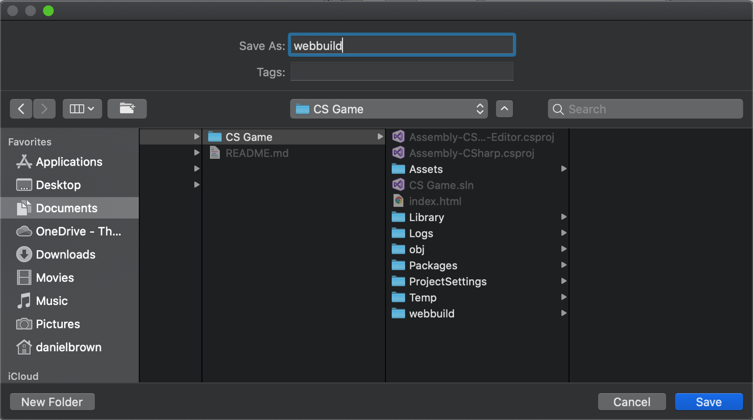
5. The build does usually take a bit of time
6. Once the build is done, copy in the old index.html to the build folder to keep your old page layout, no changes need to be done to make it work with the new build
7. If you need to edit the webpage layout, it is as simple as editing the HTML file as you would any other webpage
8. If you need to test, by default you have to run a local server to make the unity game play in most browsers, you can’t just open the html file in the browser from a file url in most of them
9. Once this is done, you can follow the update build settings to update the server build

# Database

The data base is accessed on <https://console.firebase.google.com/>

To create a new one

1. Add a project

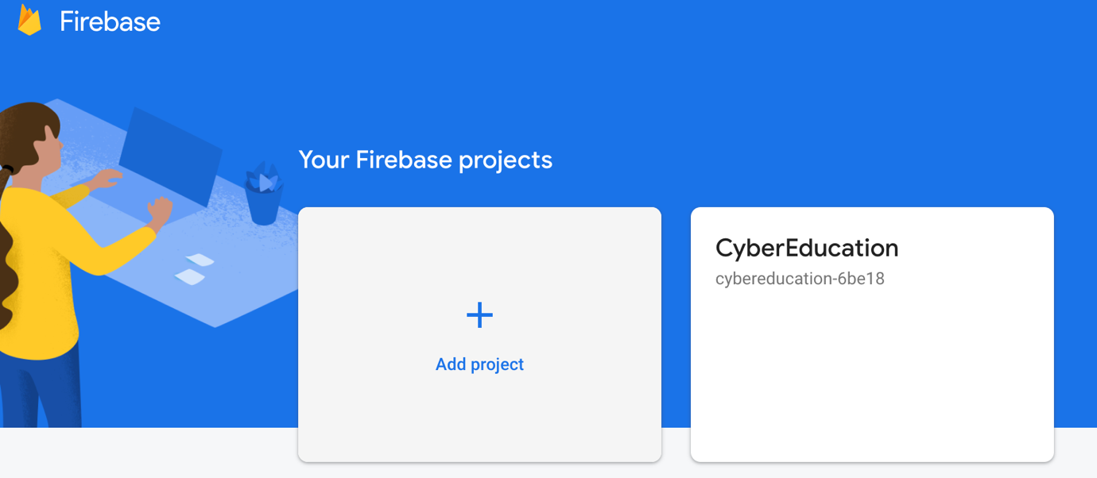

1. Select the project to add it to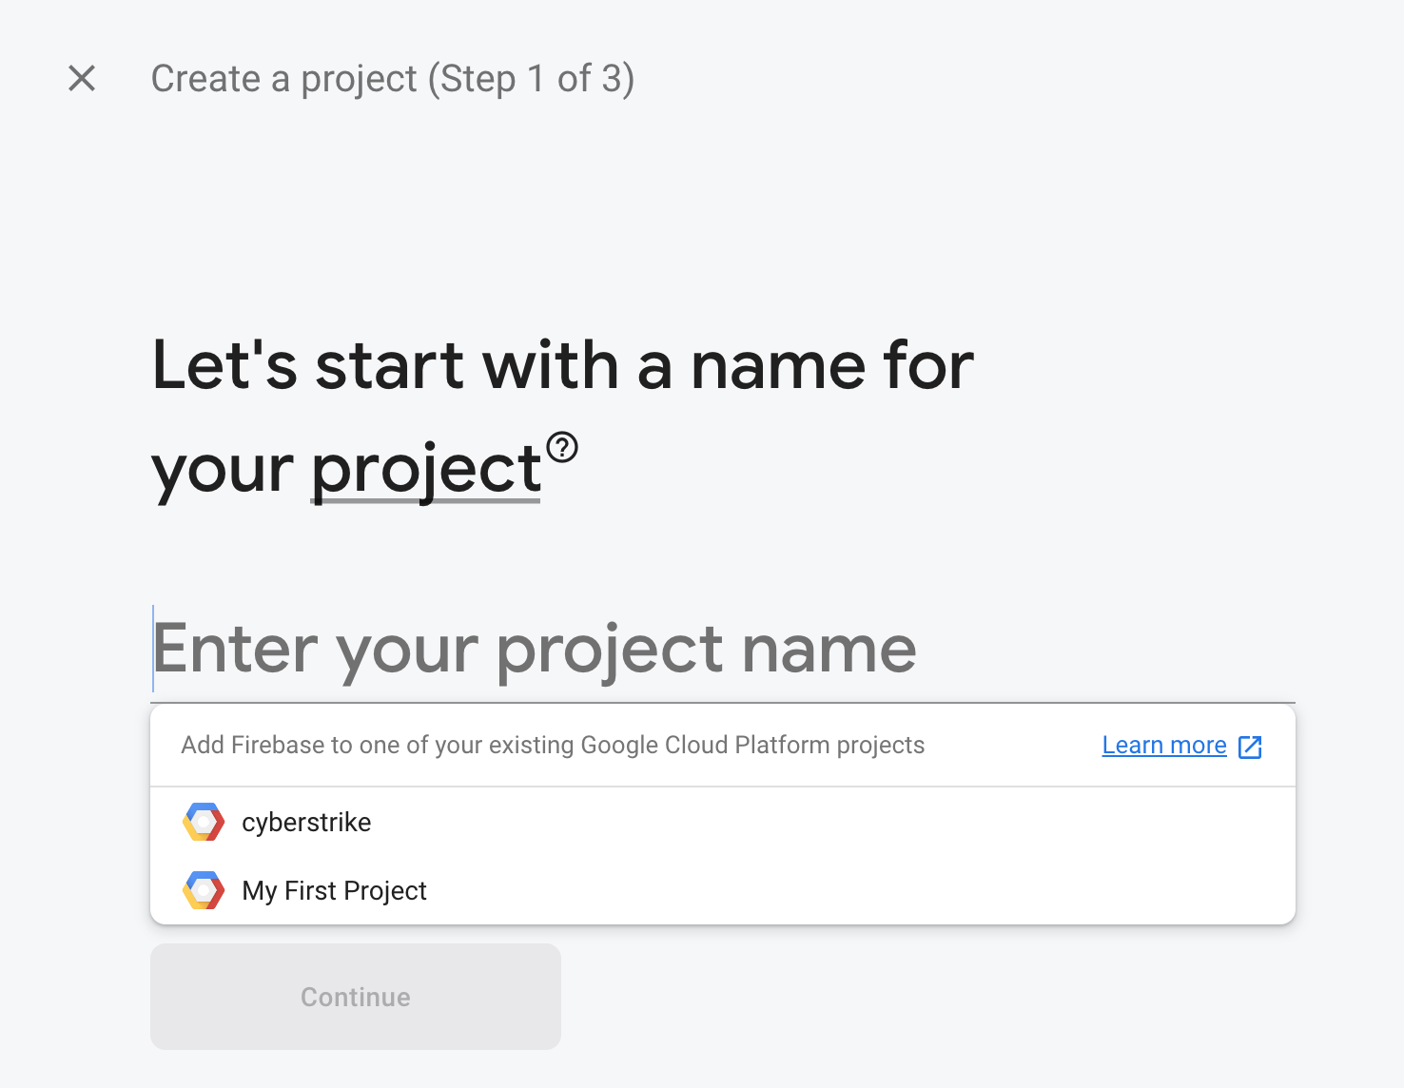
2. Create a real time database, not firestore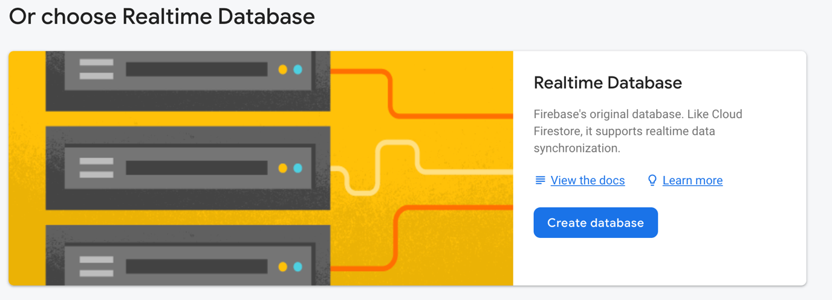
3. I started mine in test mode to allow any read and writes

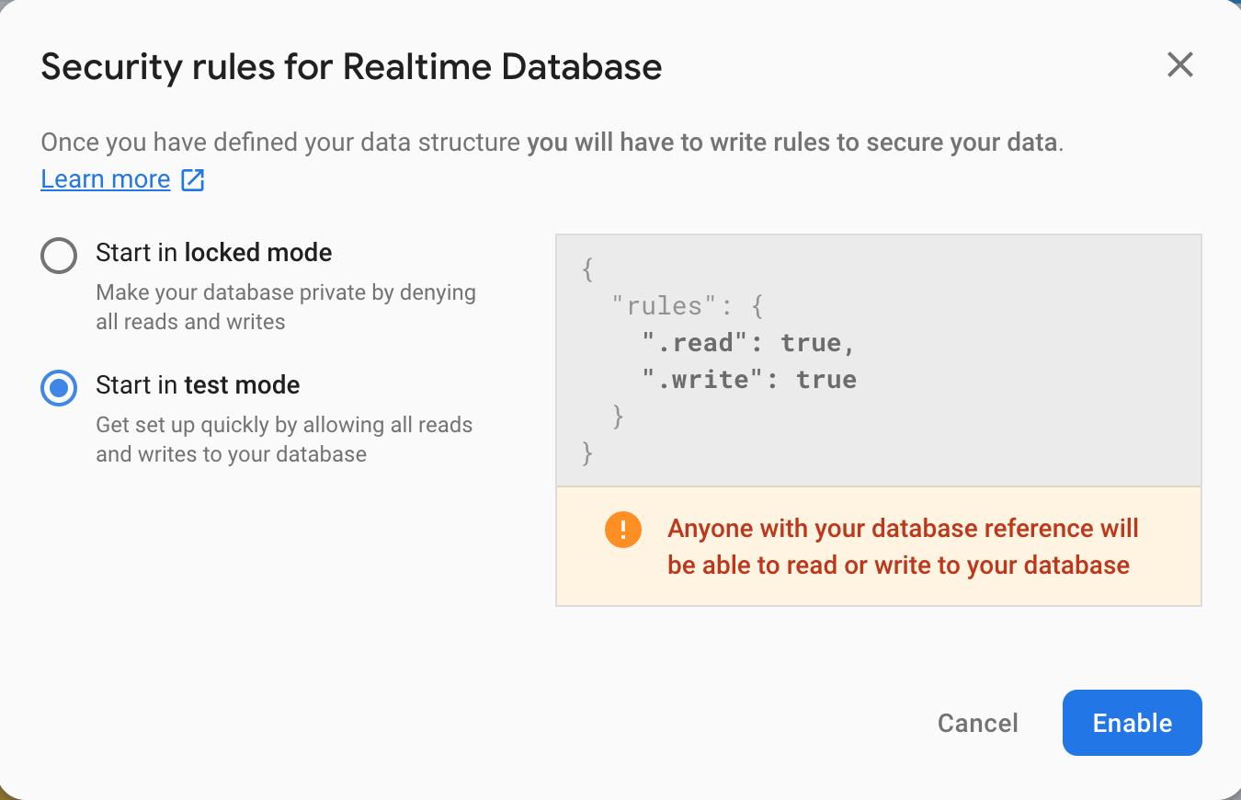

1. This is what it looks like up and running, note realtime database at the top not cloud firestore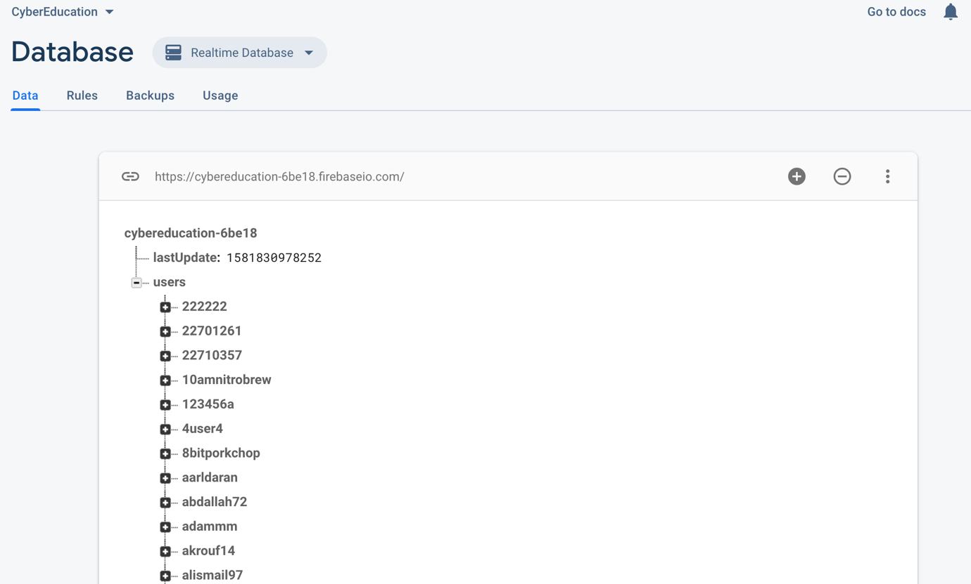
2. You can edit the rules in the other tab to secure the database, in test mode it allows anyone access
3. The database access is in the unity code, you need to change the url to the one in your database in the utility file



1. After the realtime database is set up and the code is changed, it should just work as desired, no other setup or changes needed
2. It is simple to move the user data over also, simple click the 3 dots on the original database in the top right and select export JSON, and then import this to the other database